## Clarinda logo

**Yard Duty and Supervision Policy**

**Help for non-English speakers**

If you need help to understand the information in this policy please contact Clarinda Primary School on 95443231 or [clarinda.ps@education.vic.gov.au](mailto:clarinda.ps@education.vic.gov.au)

## **PURPOSE**

To ensure school staff understand their supervision and yard duty responsibilities.

**Scope**

This policy applies to all teaching and non-teaching staff at Clarinda Primary School, including education support staff, casual relief teachers and visiting teachers.

## **Policy**

Appropriate supervision is an important strategy to monitor student behaviour and enables staff to identify and respond to possible risks at school as they arise. It also plays a vital role in helping schools to discharge their duty of care to students.

The Principal is responsible for ensuring that there is a well organised and responsive system of supervision and yard duty in place during school hours, before and after school, and on school excursions and camps and other school activities.

School staff are responsible for following reasonable and lawful instructions from the Principal, including instructions to provide supervision to students at specific dates, times and places. Supervision should be undertaken in a way that identifies and mitigates risks to child safety.

## Before and after school

Clarinda Primary School’s grounds are supervised by school staff from 8:50 until 3:45. Outside of these hours, school staff will not be available to supervise students.

Parents and carers will be advised through regular reminders in our newsletter that they should not allow their children to attend Clarinda Primary School outside of these hours. Families will be encouraged to contact Camp Australia on 1300 105 343/ [info@campaustralia.com.au](mailto:info@campaustralia.com.au) or refer to [www.campaustralia.com.au/schools/1F69](http://www.campaustralia.com.au/schools/1F69) for more information about the before and after school care facilities available to our school community.

If a student arrives at school before supervision commences at the beginning of the day, the Principal or nominee staff member will, as soon as practicable, follow up with the parent/carer to:

* advise of the supervision arrangements before school
* request that the parent/carer make alternate arrangements.

If a student is not collected before supervision finishes at the end of the day, the Principal or nominee staff member will consider whether it is appropriate to:

* attempt to contact the parents/carers
* attempt to contact the emergency contacts
* place the student in an out of school hours care program (if available and the parent consents)
* contact Victoria Police and/or Child Protection to arrange for the supervision, care and protection of the student.

## **Yard duty**

All teaching staff at Clarinda Primary School are expected to assist with yard duty supervision and will be included in the weekly roster.

The Assistant Principal is responsible for preparing and communicating the yard duty roster on a regular basis. At Clarinda Primary School, staff will be designated a specific yard duty area to supervise.

**Yard duty zones**

The designated yard duty areas for our school (as at term 2 2022 are outlined below)

|  |  |
| --- | --- |
| **Area** | **Area** |
| Area 1 | Junior school playground, quadrangle near hall and area in and around rooms 1 & 2 |
| Area 2 | Oval on main site, eastern side of school along Eulinga Road and senior school playgrounds  Student toilets |
| Area 3 – lunch times only | Oval on far side of school between Elder Street and Eulinga Road |

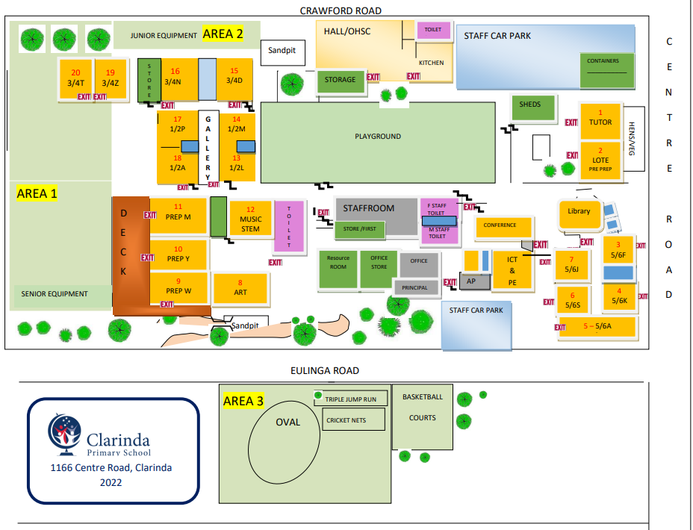

School staff must:

* wear a provided safety/hi-vis vest whilst on yard duty. Safety/hi-vis vests are provided to all staff members and spares will be stored in the school office
* carry the yard duty first aid bag at all times during supervision. The yard duty first aid bag will be stored in the Staff Room.
* Be familiar with the yard duty information pack containing student health and safety information stored in the yard duty bag in the Staff Room

Yard duty equipment must be returned after the period of supervision or handed to the relieving staff member.

**Yard duty responsibilities**

Staff who are rostered for yard duty must remain in the designated area until they are replaced by a relieving staff member.

During yard duty, supervising school staff must:

* methodically move around the designated zone ensuring active supervision of all students
* where safe to do so, approach any unknown visitor who is observed on school grounds without a clear legitimate purpose, and ensure they have a visitor pass and have signed in (excluding drop off and collection periods)
* ensure students remain in their designated year level zones
* be alert and vigilant
* intervene immediately if potentially dangerous or inappropriate behaviour is observed in the yard
* enforce behavioural standards and implement appropriate consequences for breaches of safety rules, in accordance with any relevant disciplinary measures set out in the school’s
  + Student Engagement and Wellbeing policy
  + Anti-Bullying Policy
* ensure that students who require first aid assistance receive it as soon as practicable
* log any incidents or near misses as appropriate If being relieved of their yard duty shift by another staff member (for example, where the shift is ‘split’ into 2 consecutive time periods), the staff member must ensure that a brief but adequate verbal ‘handover’ is given to the relieving staff member in relation to any issues which may have arisen during the first shift.

If the supervising staff member is unable to conduct yard duty at the designated time, they shouldcontact the Assistant Principalwith as much notice as possible prior to the relevant yard duty shift to ensure that alternative arrangements are made.

If the supervising staff member needs to leave yard duty during the allocated time, they should contact the Assistant Principalbut should not leave the designated area until the relieving staff member has arrived in the designated area.

If a relieving or next staff member does not arrive for yard duty, the staff member currently on duty should contact the office and not leave the designated area until a replacement staff member has arrived.

Students will be encouraged to speak to the supervising yard duty staff member if they require assistance during recess or lunchtime.

## **Classroom**

The classroom teacher is responsible for the supervision of all students in their care during class.

If a teacher needs to leave the classroom unattended at any time during a lesson, they should first contact the year level coordinator or the Principal of Assistant Principal for assistance. The teacher should then wait until another staff member has arrived at the classroom to supervise the class prior to leaving.

## **School activities, camps and excursions**

The Principal and leadership team are responsible for ensuring that students are appropriately supervised during all school activities, camps and excursions, including when external providers are engaged to conduct part or all of the activity. Appropriate supervision will be planned for school activities, camps and excursions on an individual basis, depending on the activities to be undertaken and the level of potential risk involved, and will follow the supervision requirements in the Department of Education and Training [Excursions Policy](https://www2.education.vic.gov.au/pal/excursions/policy).

## **Digital devices and virtual classroom**

Clarinda Primary School follows the Department’s [Cybersafety and Responsible Use of Technologies Policy](https://www2.education.vic.gov.au/pal/cybersafety/policy) with respect to supervision of students using digital devices.

Clarinda Primary School will also ensure appropriate supervision of students participating in remote and flexible learning environments while on school site. In these cases, students will be supervised in the closest break out space/ common area to their regular classroom.

While parents are responsible for the appropriate supervision of students accessing virtual classrooms from home:

* student attendance will be monitored daily
* any wellbeing or safety concerns for the student will be managed in accordance with our usual processes – refer to our Student Wellbeing and Engagement Policy and our Child Safety Responding and Reporting Policy and Procedures for further information.

## **Students requiring additional supervision support**

Sometimes students will require additional supervision, such as students with disability or other additional needs. In these cases, the Principal or delegate will ensure arrangements are made to roster additional staff as required. This may include on yard duty, in the classroom or during school activities.

## **Supervision of student in emergency operating environments**

In emergency circumstances our school will follow our Emergency Management Plan, including with respect to supervision.

In the event of any mandatory period of remote or flexible learning our School will follow the operations guidance issued by the Department.

**COMMUNICATION**

This policy will be communicated to our school community in the following ways:

* Available publicly on our school’s website
* Included in staff induction processes
* Included in staff handbook/manual
* Included in transition and enrolment packs
* Discussed at parent information nights/sessions
* Reminders in our school newsletter
* Discussed in student forums
* Hard copy available from school administration upon request

**Further Information and Resources**

* the Department’s Policy and Advisory Library (PAL):
  + [Child Safe Standards](https://www2.education.vic.gov.au/pal/child-safe-standards/policy)
  + [Cybersafety and Responsible Use of Technologies](https://www2.education.vic.gov.au/pal/cybersafety/policy)
  + [Duty of Care](https://www2.education.vic.gov.au/pal/duty-of-care/policy)
  + [Excursions](https://www2.education.vic.gov.au/pal/excursions/policy)
  + [Supervision of Students](https://www2.education.vic.gov.au/pal/supervision-students/policy)
  + [Visitors in Schools](https://www2.education.vic.gov.au/pal/visitors/policy)
  + [Work Experience](https://www2.education.vic.gov.au/pal/work-experience/policy)

**POLICY REVIEW AND APPROVAL**

|  |  |
| --- | --- |
| Policy last reviewed | July 2022 |
| Approved by | School Council |
| Next scheduled review date | 2024 |

This policy will also be updated if significant changes are made to school grounds that require a revision of Clarinda Primary School’s yard duty and supervision arrangements.