Principal: Robert Mallett

1166 Centre Road, CLARINDA 3169
Phone: (03) 9544 3231 Fax (03) 9543 8839
ABN 43 853 502 127
clarinda.ps@edumail.vic.gov.au

Dear Parent,

May I take this opportunity to welcome you and your child to our school. I feel sure that your child’s stay will be a happy and enriching one.

If your child is entering the first school year, a number of social and emotional adjustments may have to be made. So it is extremely important that a sound relationship does exist between home and school.

I can assure you that we will do our utmost to cooperate with you, do all we can to encourage and stimulate your child in all school activities and create an atmosphere of security and contentment.

School begins at 8.50am sharp and students are expected to be in class at this time to receive instructions from their teacher on the schedule and expectation for the day. School finishes at 3.30pm each day (except on the last day of each term when the students finish at 2.30pm).

Attendance: We all want our students to be enriched with a great education, and the building blocks for a great education begin with students coming to school each and every day.
Missing school can have a major impact on a child’s future – a student missing one day a fortnight will miss four full weeks by the end of the year. By Year 10 they’ll have missed more than a year of school.
If your child is absent from school, a note or a telephone call to the school office is necessary to inform the teacher of the reason for the absence.

We ask that sick children be kept home, as the school does not have facilities to care for them.

Reporting to parents

Term 1 During the first few week’s individual parent/teacher interviews will be arranged to develop cooperation and rapport between teachers and parents.

Term 2 At midyear students’ written reports are sent home and individual parent/teacher interviews will be arranged to discuss these reports and set Individual Learning Plans (ILP) for the second semester.

Term 4 In December written reports for students are sent home. Individual interviews are optional for both teachers and parents.

It should be noted that parents and / or teachers may arrange additional interviews through the Principal, or Assistant Principal at any time.

Interpreters are available for assistance with communication with parents when necessary.

Yours sincerely,

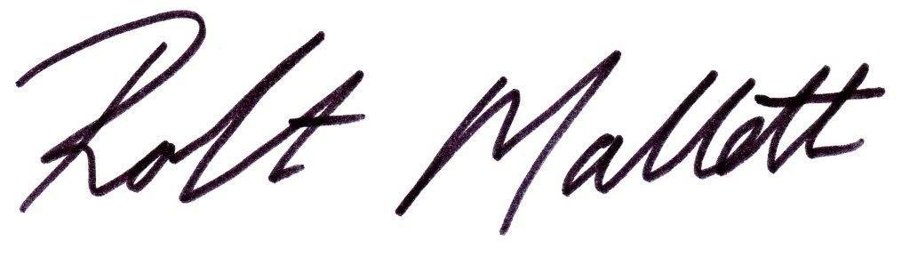

Robert Mallett
Principal
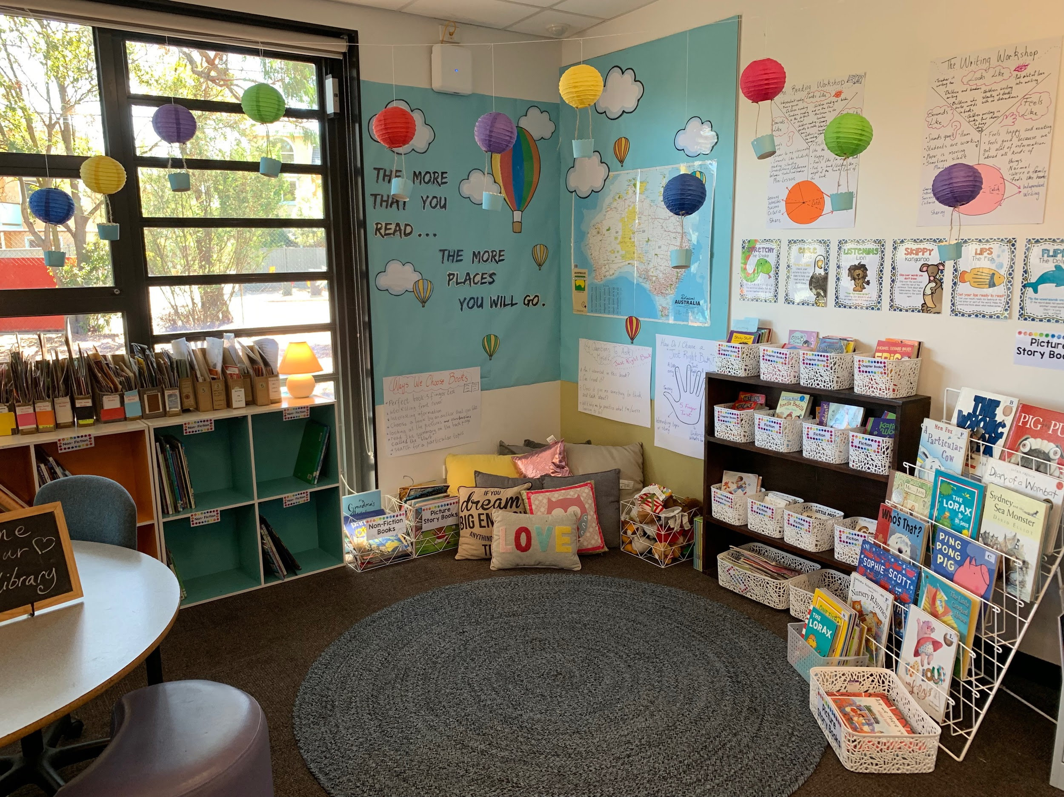
Library Corners

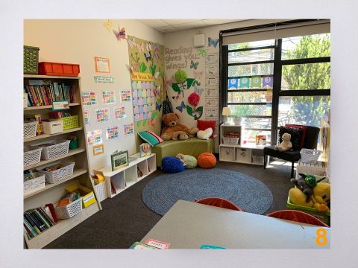
Reading
gives you
wings

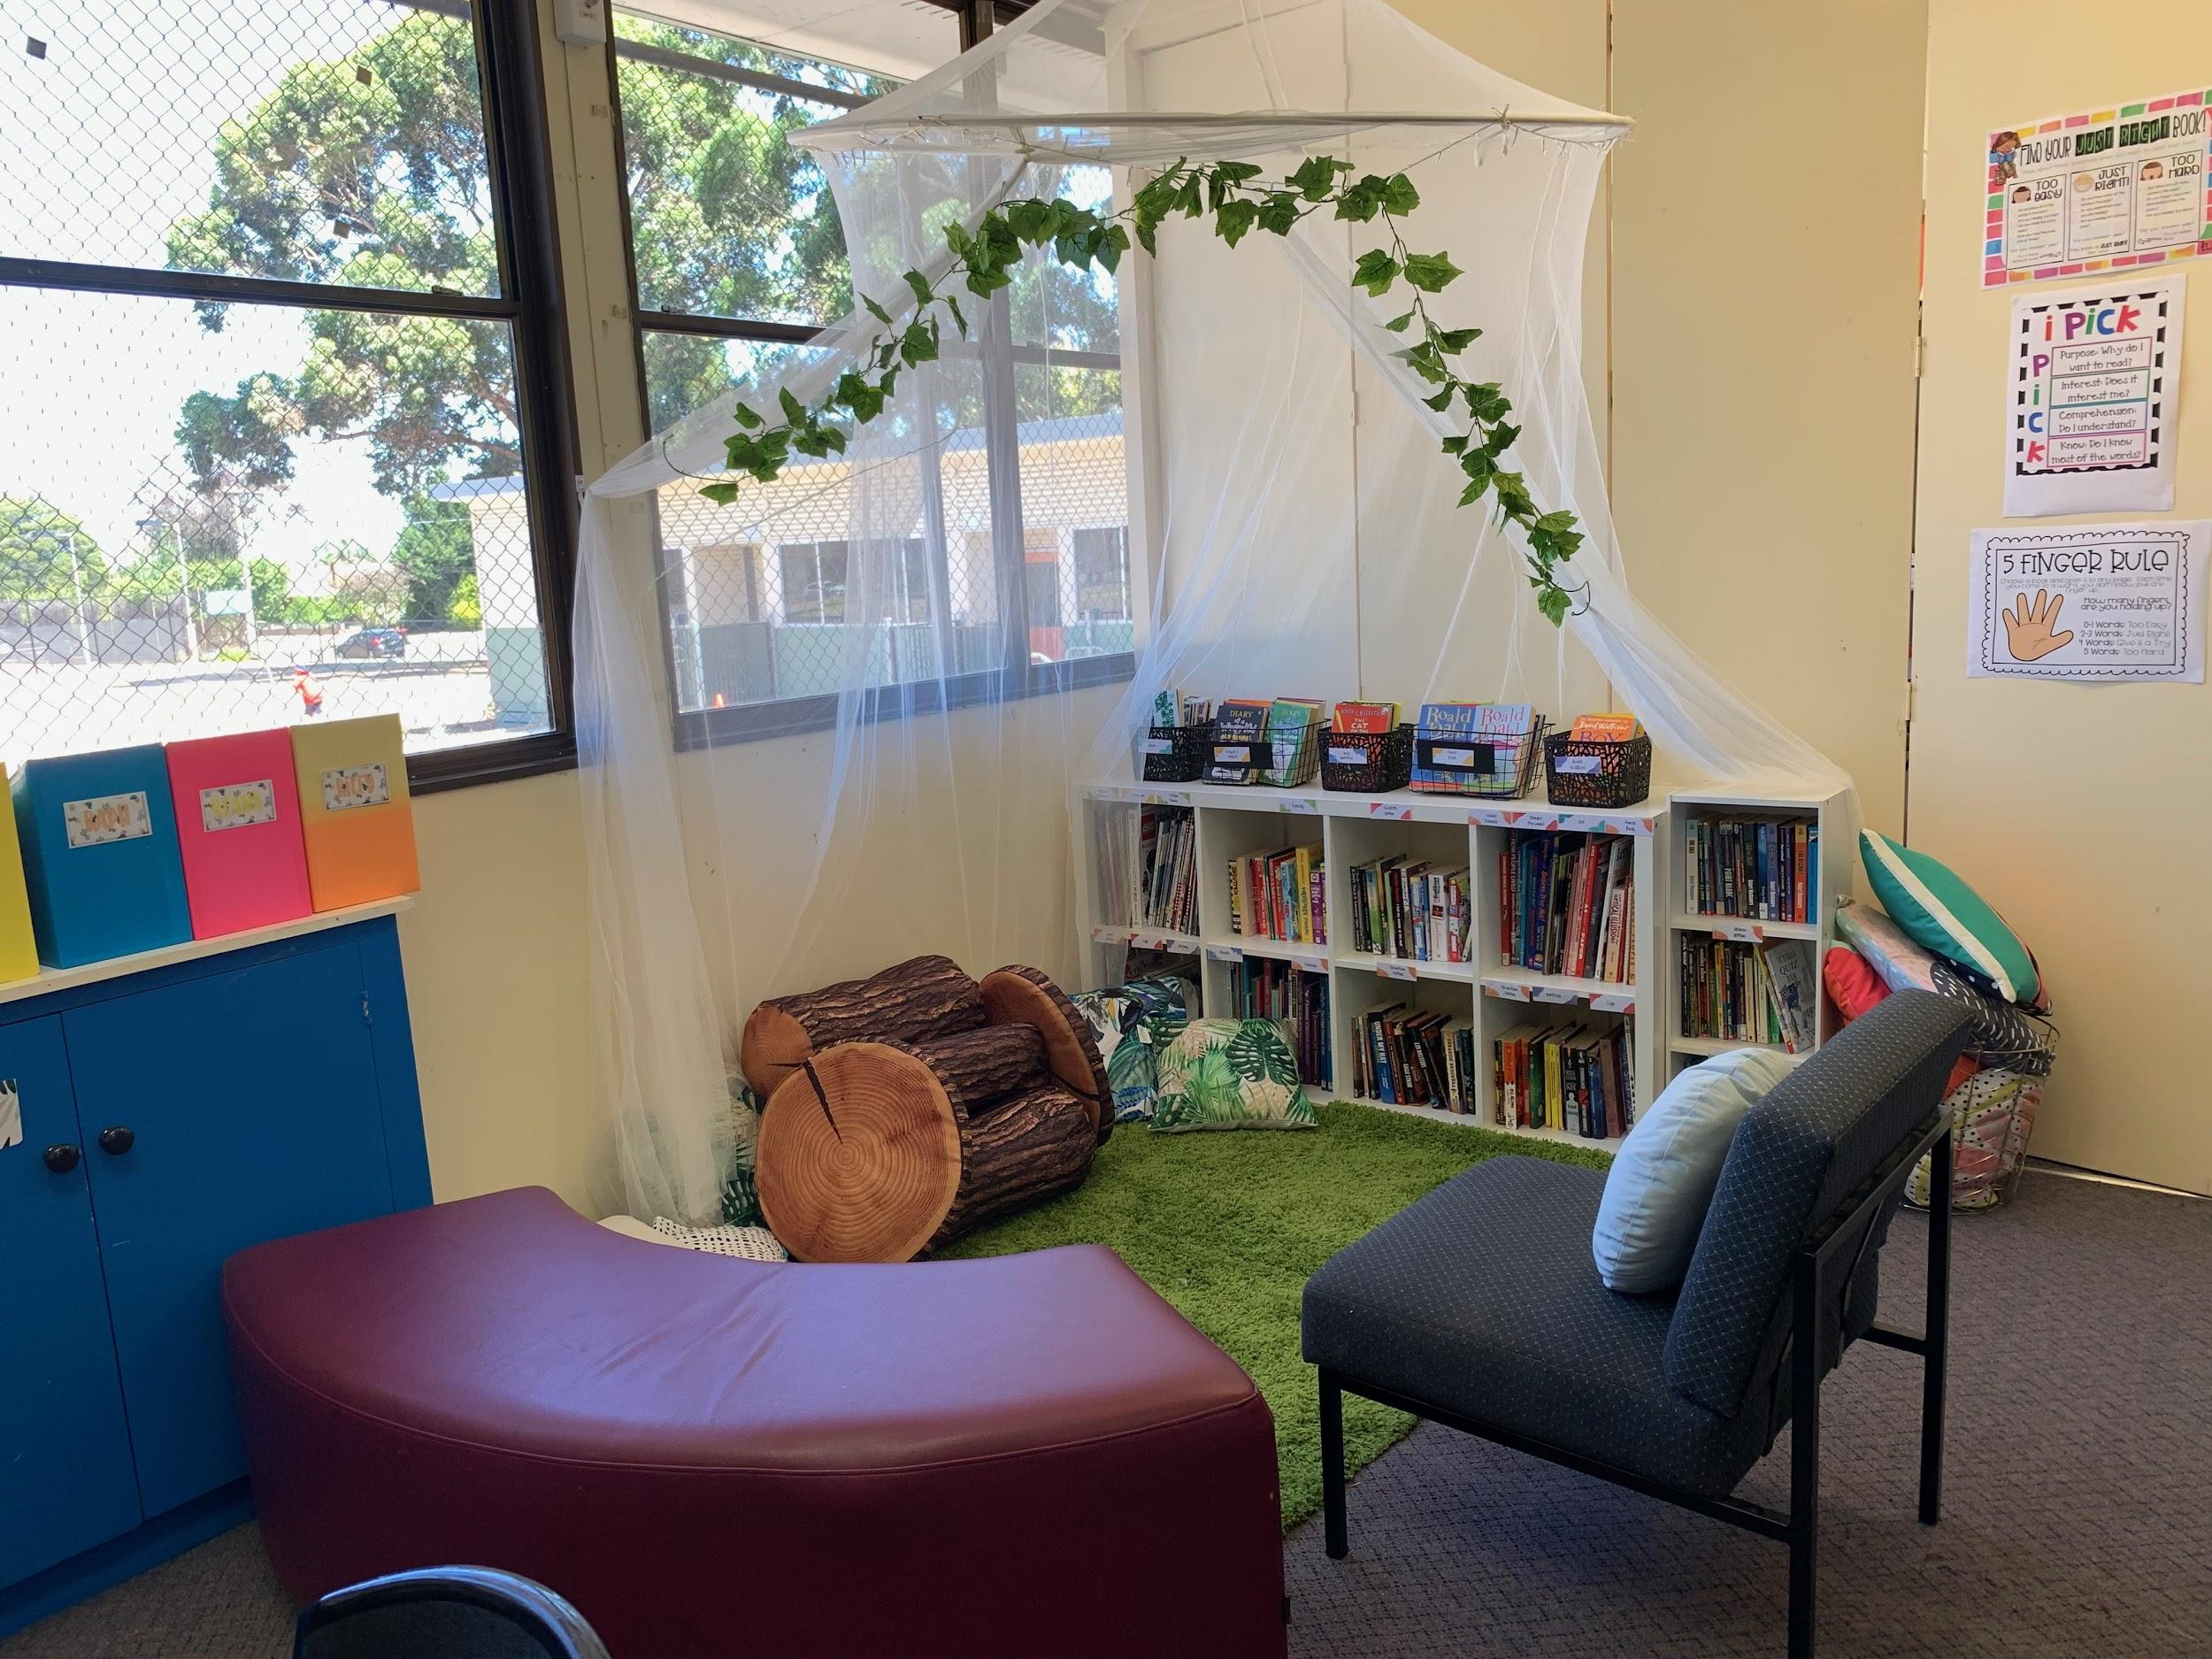
Pick a book
using the
five finger
rule

School Profile

Clarinda Primary School, with a population of 374, is situated in a neatly maintained residential suburb, in the vicinity of several large parks and golf courses. Clarinda is located within the City of Kingston, to the south east of Melbourne.
The school community is continually working to maintain and develop the school’s buildings and grounds to provide a safe and stimulating environment for all students. Notable features of our school are a modern well-equipped library, a multi-purpose hall, a large art/craft room, music room and advanced computer learning technology equipment.
Facilities exist for students with physical disabilities.

The school site is large with both active and passive areas for student and community use. The well maintained grounds include two large grassed playing fields, extensive shade areas, sand play, seating and gardens, vegetable garden/chicken coop, netball and basketball courts, three modern adventure playgrounds designed specifically to cater for junior and senior students and a student stage area.
The staff at Clarinda, supported by the School Council, have established an atmosphere of warmth and friendliness towards all members of the school community and visitors to the school. With students from a wide variety of cultural backgrounds and in many cases speaking a language other than English at home, our school has embraced multiculturalism, inclusion and equality.
Our School Vision is:
We promote an engaging, inclusive and supportive education that empowers students
to become life long learners.

In order that our students may participate confidently and positively to our ever changing society, our school promotes the values of:
C Care
A Achieve
R Respect
E Excel

 | self-esteem and resilience |  | social skills
 | responsibility, self-reliance and leadership |  | co operation
Our school expects that students will learn in a caring supportive environment which fosters the development of:

The school prescribes a seven year sequential comprehensive curriculum in each of:
English, Mathematics, Science, Technology, Health and Physical Education, The Arts,
Humanities and Language (Greek) with specialist programs operating in STEM (Science, Technology, Engineering & Maths), Art, Library, Languages (Greek), Music, Physical
Education and English as an Additional Language (EAL).
Networked multimedia laptops, interactive televisions and iPads™ are in every classroom
and support curriculum programs.
Individual programs operate within the school curriculum to meet the requirements of students with special needs.
In addition a wide range of special programs operate to address the specific needs of our student population:
Reading Recovery, Reading Improvement, School Concert, Student Choir, Social Skills, Life Education, a Buddy System, Junior School Council, Library Club, Perceptual Motor Program (PMP), Inter/Intra School Sport, Camps, Swimming and Before and After School Care.
We also provide an innovative pre-prep transition program for 3 and 4 year olds.
Parents participate in many facets of school organisation, contribute to policy development and play an active role in the support of curriculum and maintenance programs. Our Strategic Plan priorities are Literacy, Mathematics and Student Voice.

Curriculum Profile(may be subject to change)

Core Subjects: Literacy, Numeracy, Science, Information Computer Technology (ICT), Health and Humanities.

Specialist Subjects - Time allocation per week 1 lesson = 50 minutes
SUBJECT | FOUNDATION  (PREP) | YEAR 1 | YEAR 2 | YEAR 3 | YEAR 4 | YEAR 5 | YEAR 6
VISUAL ARTS | 1 lesson | 1 lesson | 1 lesson | 1 lesson | 1 lesson | 1 lesson | 1 lesson
STEM |  |  |  | 1 lesson | 1 lesson | 1 lesson | 1 lesson
PHYSICAL EDUCATION | 1 lesson | 1 lesson | 1 lesson | 1 lesson | 1 lesson | 1 lesson | 1 lesson
LANGUAGE - Greek | 1 lesson | 1 lesson | 1 lesson | 1 lesson | 1 lesson | 1 lesson | 1 lesson
PERFORMING ARTS/ MUSIC | 1 lesson | 1 lesson | 1 lesson | 1 lesson | 1 lesson | 1 lesson | 1 lesson
LIBRARY | 1 lesson | 1 lesson | 1 lesson | 1 lesson | 1 lesson | 1 lesson | 1 lesson

We also offer an extensive range of curriculum opportunities - Time allocation:
SUBJECT | FOUNDATION  (PREP) | YEAR 1 | YEAR 2 |  | YEAR 3 | YEAR 4 | YEAR 5 | YEAR 6
ENGLISH as an ADDITIONAL LANGUAGE (EAL) | As required – needs basis
SWIMMING Annually (TBC) | 8 day intensive program term 4 (optional - additional cost)
LITERACY IMPROVEMENT PROGRAM |  | Small groups at  each level weekly
GREEK Mother Tongue | 1 session weekly  Plus opportunity for after school program for 1 hour (optional - additional cost)
PERCEPTUAL MOTOR PROGRAM (PMP) | 1 session weekly
INTERSCHOOL SPORT |  |  |  |  |  |  | 2 hours p/w over two terms when applicable  (Bus costs payable)
INTEGRATION | As required
PROTECTIVE BEHAVIOURS | Regular introductory program
JUNIOR SCHOOL COUNCIL |  | Elected members to represent grades – meet twice per term
CAMPS |  |  |  |  | Sleep over  (Additional cost) | 3 - 5 days  (Additional cost)
SCHOOL SPORT |  |  |  | 1 session in addition to weekly PE lesson |  |  | Intra-school sport  2 sessions per week
University of NSW  ICAS COMPETITIONS |  |  |  |  | Annually  (optional - additional cost)
School Council

The Council is an elected and constituted legal entity. The composition and activities of the School Council are governed by a constitution made in accordance with the Education and Training Reform Act 2006, Education and Training Reform Regulations 2017 and Ministerial Order No. 52 – School Council Composition and Elections Order.

Composition of the School Council
The present Council consist of fourteen members;
8 elected parents 3 Department of Education employees
the Principal of the school 2 Co-opted members

The duties of the School Council - are outlined by the Education (School Councils) Act, 1993 as follows:

1. A Council shall, with regard to the school;
a) determine the general educational policy of the school within the guidelines issued by the Minister;
b) exercise a general oversight of the buildings and grounds and ensure that they are kept in good order and condition;
c) make any recommendations it thinks necessary for or with respect to the replacement or alteration of any buildings, and generally for or with respect to, the making of improvements to the buildings and grounds;
d) provide for the necessary cleaning and sanitary services;
e) ensure that all moneys coming into the hands of the Council are expended for proper purposes;
f) endeavour to arrange suitable accommodation for teachers appointed to the school;
g) carry our any prescribed duties;
h) generally stimulate interest in the school.

2. A Council shall publish each year, for the benefit of persons interested in the school, a report of its activities containing a copy of the last statement of receipts and expenditure sent to the Auditor General pursuant to section 15F.

3. Meetings;
The Council normally meets twice per term in the staffroom at 7.00pm on
Tuesday evenings.

4. Sub-committees;
The Council has established sub-committees;
Finance Education/Promotion
Buildings and Grounds Parents’ Club

The Convenor (selected by the Council) of each of the sub-committees has formed a small group to develop ideas and recommendations to present to the Council for consideration and appropriate action.

School Policies

Our school policies can be found on our website: www.clarindaps.vic.edu.au
Student Welfare and Discipline

A firm but fair student code of conduct has been developed and successfully implemented over a number of years to make sure that all children:

- Have the right to be safe
- Have the right to be treated with respect
- Have the right to work and play without interference

To enable this to happen, a set of school wide rules has been established and each class develops classroom rules at the start of the year.

School and classroom rules are sent home to provide parents with the opportunity to comment on their suitability, and to support the school by discussing the plans with their children.

The teachers use the Assertive Discipline Program to maintain effective discipline in all classes. It is a most effective approach to behaviour management, which fosters a positive climate of personal responsibility and self-discipline.

The welfare of the children has been enhanced by the following positive initiatives:

- Excellent curriculum development

- Social skills lessons

- Student council

- English as an additional language (EAL) assistance

- Integration program

- Junior School Council (Including School and House Captains)

- Year 5/Foundation (Prep) Buddy System

- Life Education Van – bi-annually

- Literacy Improvement Program

Specialist Support Staff

The Department of Education and Training provides a limited number of specialist support staff, who are not based at the school, but are available to schools and parents.
These include;
*Guidance Officers *Speech Therapists *Social Workers *Visiting Teachers

School Nursing Service

The visit of the school nurse will take place during the course of the year.

The nurse, with parent permission, reviews every child in the Foundation (Prep) year. She may also see children in other year levels on request from a teacher and/or parent.

Attendance and Punctuality

Every day counts
We all want our students to get a great education, and the building blocks for a great education begin with students coming to school each and every day.
If your child is absent from school, a note or a telephone call to the school office is necessary to inform the teacher of the reason for the absence.

We ask that sick children be kept home, as the school does not have facilities to care for them.
Missing school can have a major impact on a child’s future – a student missing one day a fortnight will miss four full weeks by the end of the year. By Year 10 they’ll have missed more than a year of school.
There is no safe number of days for missing school – each day a student misses puts them behind, and can affect their educational outcomes.
Coming to school every day is vital, but if for any reason your child must miss school, there are things we can do together to ensure they don’t fall behind:
- Speak with your classroom teacher and find out what work your child needs to do to keep up.
- Develop an absence learning plan with your teacher and ensure your child completes the plan.
Remember, every day counts. If your child must miss school, speak with your classroom teacher as early as possible.
If you’re having attendance issues with your child, please let your classroom teacher know so we can work together to get your child to school every day.
Punctuality: School starts at 9.00am and students are expected to be in class at this time to receive instructions from their teacher on the schedule and expectations for the day.

Late Arrival to School
If your child is late to school (after 9.00am), the late arrival register must be signed at the office.
A student late arrival note will be issued to present to the class teacher when you personally take your child to the classroom.

The Principal or Assistant Principal will follow up with families whose arrival at school is consistently late, to work out how we can support them to gain the best education outcomes for their child/ren.

Early Departure from School

If you wish your child to leave school early (e.g. a dental appointment), the early departure register must be signed at the school office. A student early departure note will be issued to present to the class teacher when you personally collect your child from the classroom.

Prior notice of intended early departure is appreciated.

Essential Education Items and Student Materials

The Department of Education and Training provides funding to each school to cover the essential cost of providing a comprehensive curriculum.

The School Council asks parents to contribute to meet the cost of student stationery and text books, additional class requisites and special programs.

The school purchases materials in bulk to distribute to each class as required. This list includes all exercise books, text books, folders, loose leaf paper refills, jotters, initial supply of pens, pencils, rulers, glue sticks, coloured pencils, textas, erasers, pencil cases, report cards, additional art supplies, mathematics equipment and reading materials.

Financial Assistance – Camps, Sports & Excursions Fund (CSEF)

Every Victorian child should have access to the world of learning opportunities that exist beyond the classroom. The Camps, Sports and Excursions Fund will ensure that no student will miss out on the opportunity to join their classmates for important, educational and fun activities.

CSEF will be provided by the Victorian Government to assist eligible families to cover the costs of school trips, camps and sporting activities.

If you hold a valid means-tested concession card or are a temporary foster parent, you may be eligible for CSEF. The allowance will be paid to the school to use towards expenses relating to camps, excursions, or sporting activities for the benefit of your child.

How to apply
Contact the school office to obtain a CSEF application form or download from www.education.vic.gov.au/csef. The allowance can be applied for in Terms 1 or 2 each year.

Homework

Homework may be set in all grades at the discretion of the class teacher. The amount of time necessary will vary according to the age of the child.

Please refer to the Homework Policy on our website.

Book Club

The school operates as an agent for a Book Club that offers books at reasonable prices.

Catalogues are distributed to the children once a term.
Orders should be returned, named, with cash or a cheque made out to Scholastic Australia or paid for online.

Delivery follows to school in approximately four weeks.

School Library

Our library is well stocked with novels by popular children’s author. It is a valuable resource helping students locate information they need for school assignments and in following up their personal hobbies. The library assists teachers in carrying out the school program by obtaining and providing materials relevant to the School Curriculum.

Apart from books that enrich the children’s knowledge in curriculum subjects, the library also provides information technology resources, pictures, charts, study prints, pamphlets, educational games and magazines. A teacher helps children make use of these resources, provides instruction and practice in library research skills and encourages class discussion on books read by the children themselves.

The children take part in the organisation of the library by carrying out duties as library monitors thus experiencing responsibility in borrowing, self-checking and being responsible for various library resources.

All grades spend a minimum of one structured period per week in the library and this incorporates research skills and library procedures. Research time is available to all grades. Children are encouraged to borrow up to three books on a weekly basis but must remember to return them by a set date.
Lost books will incur a fee.

It is hoped that the knowledge of library operations, gained in the primary school, will enable the children to confidently approach municipal and secondary school libraries.
Swimming Program – Annually (TBC)

Clarinda Primary School offers an annual intensive swimming program to all children from Foundation (Prep) to Year 6.
We believe that it is essential for our students to become proficient swimmers. Fees are kept to the minimum. All instructors are Austswim trained and the swimming pool that we travel to is heated.

Excursions and Overnight Camps

First hand experiences are part of a vital educational program. To participate in these group outings is a valuable aspect of a child’s social development. When organising an excursion we seek your written consent and money (if required) to cover the costs.

Annual overnight camps are arranged for middle and upper grades when staff and suitable venues are available.

As an introduction to our camping program, and as part of the children’s social education, Year 3 students are able to participate in a sleepover at school each year.

The sleepover is an enjoyable way to introduce the children to an extended stay away from home, in preparation for the annual camp in years 4, 5 & 6 and a fun night where they mix with their peers in a social atmosphere.

Illness / Accident Procedure

1. The nature and extent of the injury is assessed and treated accordingly.

2. Parents are notified by phone as soon as possible for all head injuries.

3. The student’s enrolment file is checked for known conditions.

4. If parents need to be contacted or the child needs to be sent home, contact/emergency numbers are taken from the student’s enrolment file.

5. If the child’s condition worsens or if the condition needs urgent medical treatment an ambulance may be called to transport the child to hospital. Parents are responsible for the cost of ambulance transport.

6. All incidents are entered into the accident file.

7. A ‘Sick Bay Attendance’ notice will be sent home with your child for any attendance at sick bay.

Emergency Information

In case of accident or illness we may need to contact you in a hurry.

Please notify the school, without delay, if you have a change in your home, mobile or work telephone number or address.

At the start of each year every family will be sent home a print out of the information held on the school computer system. This is an ideal opportunity to change any outdated information.

Medicines

Medicines, including pain relievers, which your child is to receive during school hours, must be handed to the school office with detailed instructions (a form is available from the school office).

Children are not permitted to carry any medication of any description whilst at school with the exception of asthma inhalers or an Epipen.
Asthma

If your child is an asthmatic we require you to provide us with an asthma management plan.
Your doctor is able to supply this plan or you can pick up a form from the school office.
This information will assist us if your child has an asthma attack at school.
Anaphylaxis/Allergies/Medical Conditions

If your child suffers from Anaphylaxis, Allergic Reactions or other Medical Conditions we require you to provide us with an action plan signed by your doctor and an Epipen (if applicable).

Your doctor is able to supply this plan or you can pick up a form from the school office.

This information will assist us if your child has a medical emergency at school.

Immunisation Certificate

It is a compulsory Department of Education and Training requirement that all children attending primary school provide the school with an immunisation certificate. This certificate is obtainable from: the Australian Childhood Immunisation Register (ACIR), your local Medicare Office or online at www.medicareaustralia.gov.au/online, and must be produced prior to the child commencing school. The certificate should also accompany your child when transferring between schools.

Infectious Diseases

The Department of Education and Training requires the following exclusion table to be observed in cases of infectious diseases.

Chicken Pox For at least 5 days after the beginning of the illness and until the
last lesion has healed or can be covered.

Mumps Until at least 9 days after the onset of the symptoms or until the
swelling goes down (whichever is sooner).

Measles For at least 4 days from the appearance of the rash.

Rubella For at least 4 days from the appearance of the rash.
(German Measles)

Pediculosis Any student found to have head lice shall remain at home until appropriate
(Head lice) treatment has commenced as outlined by Department of Health and Human
Services.

Others Please enquire at the school office.

Sunsmart Policy

Our Sunsmart policy has been developed to ensure that all our children are protected from skin damage caused by the harmful ultra-violet rays of the sun.
Our school will;
1. Ensure hats are worn outside in terms 1 and 4.
2. Encourage the wearing of hats which cover the face, neck and ears.
3. Encourage the use of SPF 50+ by students and staff.
4. Incorporate programs in skin cancer prevention into the curriculum.

Wet Day and Extreme Heat Procedures

If it rains between 8.35am and 8.50am, the bell will be rung for the children to enter their classrooms, where they will be supervised by their teacher and if the weather is inclement during recess or lunchtime, the children will be kept indoors.

On days of extreme heat or windy conditions a similar procedure will be implemented. The whole school is air conditioned.

Please note that recess and dismissal times will be unchanged on these days.

Parents’ and Community Club (PACC)

Our school has an active Parents’ and Community Club. All parents are very welcome to attend meetings and new parents are always encouraged to come along and participate in all functions.

The Parents’ and Community Club are a friendly group of people who get together for fundraising functions, parent social events, student special lunch days, stalls and fun days. They meet regularly and welcome new parents.

Class Photographs

Class photographs and individual photographs are taken each year. Pupils who have prepaid receive a photograph package to take home. The photographic studio pays commission into school funds on sales each year.

Clarinda Newsletter

The Clarinda Newsletter is distributed fortnightly via Enews (see Page 19 for ‘How to install or subscribe to Enews’). Our newsletter contains a timetable of events for the term and many items of general interest to the school community.

It is also available on our website: www.clarindaps.vic.edu.au

Class Newsletter

Every class issues their ‘Class Newsletter’ in the third week of every term. This newsletter includes: their specialist timetable, important dates for the term, the curriculum focus for the term, etc.

It is also available on our website: www.clarindaps.vic.edu.au

Social Media

Our website at www.clarindaps.vic.edu.au is constantly being updated, so check it regularly.
Class newsletters, School Policies, upcoming events and a host of other important information is available on the site.

The school also promotes teaching and learning through its Facebook page at www.facebook.com/clarindaprimaryschool

Class Dojo

All classes are now connected to ClassDojo. Dojo provides a private classroom communication tool which connects teachers with students and parents to build amazing classroom communities.

One function is the messaging function which is highly important as it supports effective two way communication. Staff will endeavour to respond as soon as possible. As you are aware, our school day gets quite busy and we hope you understand, if and when, it takes us longer to respond.
Student absecnes should not be reported using Dojo because of this delay.
As such, for any absences or more timely information, please call the office directly on 9544 3231

Traffic

If you drive your child to school, please observe all traffic restrictions including the 40km school zone speed limits in Crawford and Eulinga Roads. Please do not park across entrances, in the school ground, on the nature strips, in the NO STANDING areas or in the teachers’ car parks.

Five minute pick up / drop off and ‘Kiss and Go’ zones are designated in Crawford and Eulinga Roads, near the school gates.

Children MUST NOT enter or exit via the car park entrances.

Children should enter the school ground via the single pedestrian gates.
We ask that children do not climb over the fence or enter through the car park area.

Bicycles and Scooters

Bicycles and scooters may be ridden to school. Bicycle helmets are to be worn. For safety reasons, we ask that bicycles and scooters are wheeled while in the school ground.

The school has bicycle pods to secure the bikes to. The school cannot accept any responsibility for damage to or theft of bicycles.

The Clarinda Primary School Council do not recommend that children below year four ride bicycles to school.

Lunches

Children should bring a packed lunch from home.

Children are supervised while they eat their lunches in the classroom.

Occasional special lunch days will be offered during the year.

Children are able to purchase a Subway lunch on Tuesdays and Fridays.

Children are not permitted to leave the school to visit the shops.
We discourage parents coming to school with ‘fast food’ lunches for their children.

Brainy Bites and Water Bottles

Children may snack on their ‘Brainy Bite’ food before recess. Only fruit and vegetables are allowed.

Children are also encouraged to bring their own water bottle to school and keep hydrated throughout the day.

Social Service

Children are encouraged to think of others less fortunate than themselves. This is done by:

The children donating a gold coin to a class collection or a special fund raiser.

School special efforts for specific purposes e.g. Children’s Hospital Appeal, State School Relief etc.

Lost Property

Labelling All articles, including clothing, which your child brings to school should be clearly marked with your child’s full name.

Should any clothing/lunch boxes/drink bottles be lost please check the lost property box (located in the first aid room opposite the school office) as soon as possible.

All articles left lying around are placed in the lost property box until the end of term. They are then sent to charity.

Valuables It is not advisable for children to bring articles of value to school especially expensive toys, jewellery, watches, electronic devices and mobile phones. Such items are often the cause of discord among children and are likely to be lost or damaged.

If your child needs to bring a mobile phone to school it MUST be left at the school office at the start of the day and collected after school.

The school cannot accept any responsibility for any valuables brought to school.

Out of School Hours Care

Before and After school care is run by the City of Kingston.

The programs are run in our school hall and children are encouraged to take part in relaxing activities or complete homework etc.

Details of enrolment and costs are available from the City of Kingston. www.kingston.vic.gov.au/beforeandafterschoolprogram or phone 9581 4867.

Childcare Subsidy from Centrelink is available to qualifying families.

Before Care
The Before School Care program starts at 6.45am each school day.

The children receive a light breakfast.

After Care
After School Care program begins at 3.30pm and runs until 6.15pm.
A fee of $21.00 per 15 minutes or part thereof will be charged for children collected after 6.15pm.

The children receive afternoon tea

Curriculum Day Care – (if sufficient numbers allow)
Curriculum Day Care begins at 6.45am runs until 6.15pm. A fee of $21.00 per 15 minutes or part thereof will be charged for children collected after 6.15pm.

The children receive morning and afternoon tea. Children are to bring their own lunch.

School Hours and Assembly

The school day begins at 8.50am.

8.50am to 9.00am Children go into class
(Foundation (Prep) – Grade 2: Reading Program)
(Grade 3 – 6: Mindfulness Program)

9.00am to 11.00am First session

11.00am to 11.30am Morning recess

11.30am to 1.00pm Second session

1.00pm to 1.10pm Lunch in rooms

1.10pm to 2.00pm Lunch recess

2.00pm to 3.30pm Third session

As the school’s official responsibility for the children does not begin until 8.35am, we ask that children do not come to school early.
This is especially important on wet days, as there is very limited shelter available.

A school assembly is held in the hall in the first and last week of term. Parents are welcome to attend.

Dismissal time for all grades is 3.30pm, except on the last day of each term when children are dismissed at 2.30pm or as advised via the newsletter.

Term Dates 2020

Term 1
Tuesday 28th January to Friday 27th March
Tuesday 28th January - Teachers resume
Wednesday 29th January - Curriculum Day – NO STUDENTS
Thursday 30th January – Years 1 – 6 students start
Monday 3rd February - Foundation (Prep) students start

Term 2
Tuesday 14th April to Friday 26th June

Term 3
Monday 13th July to Friday 18th September

Term 4
Monday 5th October to Friday 18th December

All dates are inclusive

CLARINDA PRIMARY SCHOOL
SCHOOL UNIFORM

School uniform is compulsory at our school. The School Uniform Policy is available on our website. All children are required to wear clothing in the colours of navy blue and red at all times. Uniform purchases may be made at the school office at any time during office hours.

A selection of second-hand uniform items is also available from the school office.

Below is a comprehensive listing of our school uniform.

Tops: |  | Dresses:
Navy windcheater |  | Summer dress
Navy hemmed windcheater |  | Winter dress
Navy bomber jacket
Navy/Red polo shirt with long sleeves
Navy/Red shirt with short sleeves |  | Socks & Tights:
 |  | Navy or white socks *
 |  | Navy or white tights *
Pants:
Navy tracksuit pants |  | Shoes:
(straight leg or cuffed) |  | Black leather school shoe *
Navy cargo pants |  | Black leather boot * work boot style
Navy bootleg pants |  | Black or white runners *
Shorts: |  | Hats, Bags, Smocks:
Navy basketball style shorts |  | Navy slouch hat
Navy cargo shorts |  | School bag
Navy Skort (skirt/shorts combined) |  | Library bag
Navy sports briefs * |  | Art smock
SUNSMART POLICY
Our Sunsmart policy has been developed to ensure that all our children areprotected from skin damage caused by the harmful ultra-violet rays of the sun.
Our school will:
- Ensure hats are worn outside in Term 1 and 4
- Encourage the wearing of hats which cover the face, neck and ears
- Encourage the use of SPF 50+ by students and staff
- Incorporate programs in skin cancer prevention into the curriculum
* Denotes not available from the school office

History
Clarinda - The Early Days

The first school, on a site adjacent to the present one, was opened on June 20th 1899, in a building leased from the Presbyterian Church. The school was named “Bald Hill Leased School”, after the “hill” or rise upon which it was situated.

In 1901 the name was changed to “Bay View”. At the time “Bay View” was, of course an appropriate name, as there was an unobstructed view of the bay from the school. Even today the bay can be seen quite clearly looking south down Eulinga Road on a good day.

After much agitation from discontented parents regarding the unsatisfactory nature of the leased building, the Education Department eventually agreed to build a new school (at the cost of 303 10s ), and this was opened on September 12th, 1904 with 72 children in attendance.

By 1913 the name had been changed again - this time to “Clarinda”, the name by which the old Bald Hill area had become known.

“Clarinda” is a girl’s name, which appears in one of Robert Burns romantic poems and was obviously chosen by some of the early settlers or their descendants, who wished to maintain some link with their Scottish Homeland. Clarinda also means “Clear View”.

The 1904 building was demolished, together with later additions, when the school was rebuilt in the early 1970’s.

In 1962, Clayton West Primary School opened with between 270 and 280 pupils, of which approximately 200 were drawn from Clarinda.

Clarinda Primary School celebrated its Centenary on 20th June 1999.

At the start of 2007 Clarinda Primary School and Clayton West Primary School combined to form the new Clarinda Primary School.

In 2007 a new gallery was built in between two existing portables and a third new portable, making way for two new classrooms and a large communal space.

In 2008 & 2009 interactive whiteboards were installed in all classrooms.

In 2008 our hall was extended. It can now accommodate the whole school for assembly. It is spacious and bright, with lots of storage.

In 2010 two classrooms on the Centre Road end of the main building were demolished and a new building built, which contains 4 new classrooms and a library.

