Prep Newsletter Term 4, 2018

Important Dates:
- Friday 2nd November - Prep Transition for 2019 - No Reading Circles
- Monday 5th November - Curriculum Day - No School for Students
- Tuesday 6th November - Melbourne Cup Public Holiday
- Wednesday 7th November - Water Safety Program at Doug Ellis Swim School
- Thursday 8th November - Water Safety Program at Doug Ellis Swim School
- Friday 9th November - Water Safety Program at Doug Ellis Swim School
- Friday 16th November - Prep Transition for 2019 - No Reading Circles
- Wednesday 21st November - Parent and Community Club Meeting at 2:30pm
- Friday 23rd November - Prep Excursion to the Melbourne Zoo
- Friday 30th November - Prep Transition for 2019 - No Reading Circles
- Thursday 6th December - Christmas Concert Night
- Monday 10th December - Cross-level transition - Students to meet their 2019 teachers
- Tuesday 11th December - Prep Transition for 2019 - No Reading Circles
- Wednesday 12th December - Parent and Community Club Meeting at 2:30pm
- Monday 17th December - Cross-level transition - Students to meet their 2019 teachers
- Thursday 20th December - Semester 2 Reports sent home
- Friday 21st December - Final Day of Term 4 - Early Dismissal at 1:30pm

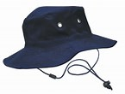
Hats
As part of our Sun Smart Policy, School hats are compulsory for all students in Term 4. Children who do not have a hat at school will be required to play in the shade. School hats are available for purchase from the School Office.
Water Safety
This year’s Water Safety program will be held on Wednesday 7th November - Friday 9th November at the Doug Ellis Swim School at Monash University. Children will be required to dress and undress themselves independently, so please prepare them for this. Parents are welcome to meet us at the pool to watch the children swim. Any parent who wishes to assist the children with dressing themselves after the water safety lessons must hold a valid Working with Children Check and provide a copy of this to the School Office.
Participation in the program is highly recommended, particularly for those children who do not take part in private lessons. It is also beneficial for children who already participate in a swimming program outside of school as the experience of travelling to the pool by bus with their peers, changing themselves, looking after their belongings and consolidating the water safety skills they are already working on, makes their involvement very worthwhile.
Talks
This term, the students will be given a talk to work on at home, which they will present at school between weeks 6 and 10. Please read the Show and Tell roster so you know when your child is due to present in front of the class. A notice with further details will be sent home.

Excursions
We are excited to have two scheduled excursions this term. Our first excursion was to Woolworths for a “Fresh Food Kids Tour” on Thursday 18th and Friday 19th October. All the Preps had a great time learning about fresh produce and seeing the back of the store before enjoying some fruit kebabs. We will have our final excursion to the Melbourne Zoo on Friday 23rd November for a “Wild Explorers Program”. An excursion notice for the Melbourne Zoo will be sent home shortly.
School arrival time
Please remember to arrive by 8:45am to be ready to commence Reading Circles. Our days are very busy and the day is timetabled to maximise teaching and learning time. As part of our Reading Program, all children need to be in line by 8:45 am. Please make every effort to arrive and have your child in the class line on time.
No nuts
As we have children at Clarinda PS who are highly allergic (anaphylactic) to peanuts and other nuts, we strongly recommend that you do not pack any nuts in your child’s lunchbox, including spreads, such as Nutella and Peanut Butter, and any other products that may contain nuts. We appreciate your assistance when preparing your child’s snacks and lunches. Please talk to your children about not sharing any food.

Remember that we are very willing to help and answer any queries you may have but the mornings are very busy preparing for the day. Please make a time to see us after school when we are more available for a chat.

Thank you for your continued support,
Elena Ziebell, Cheryl See and Natalie Telpuk

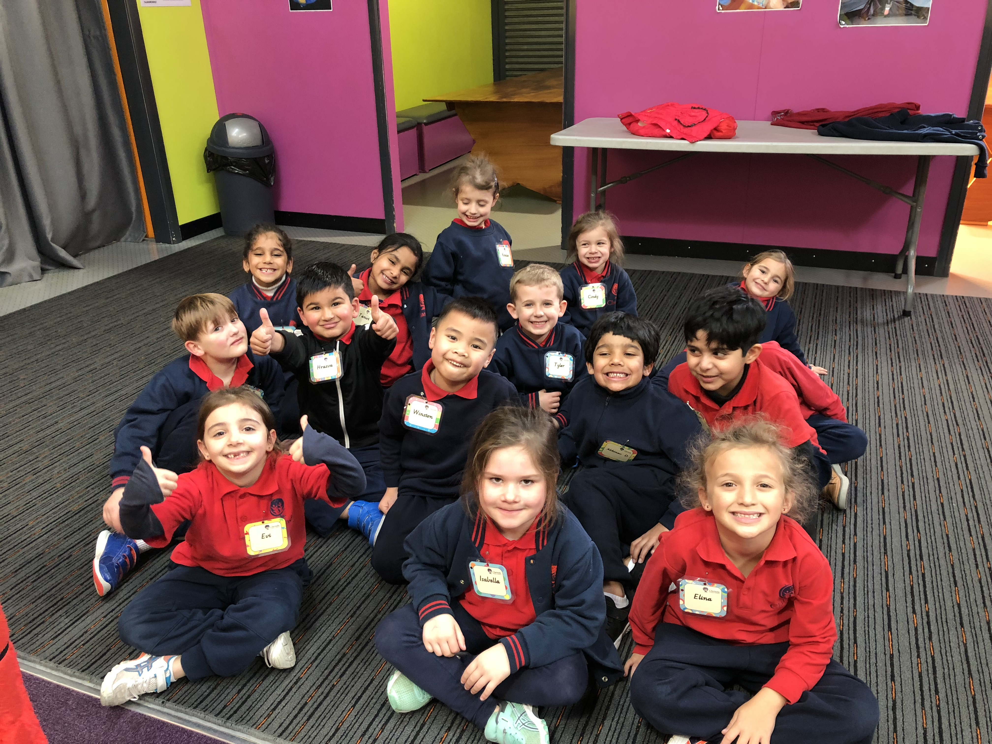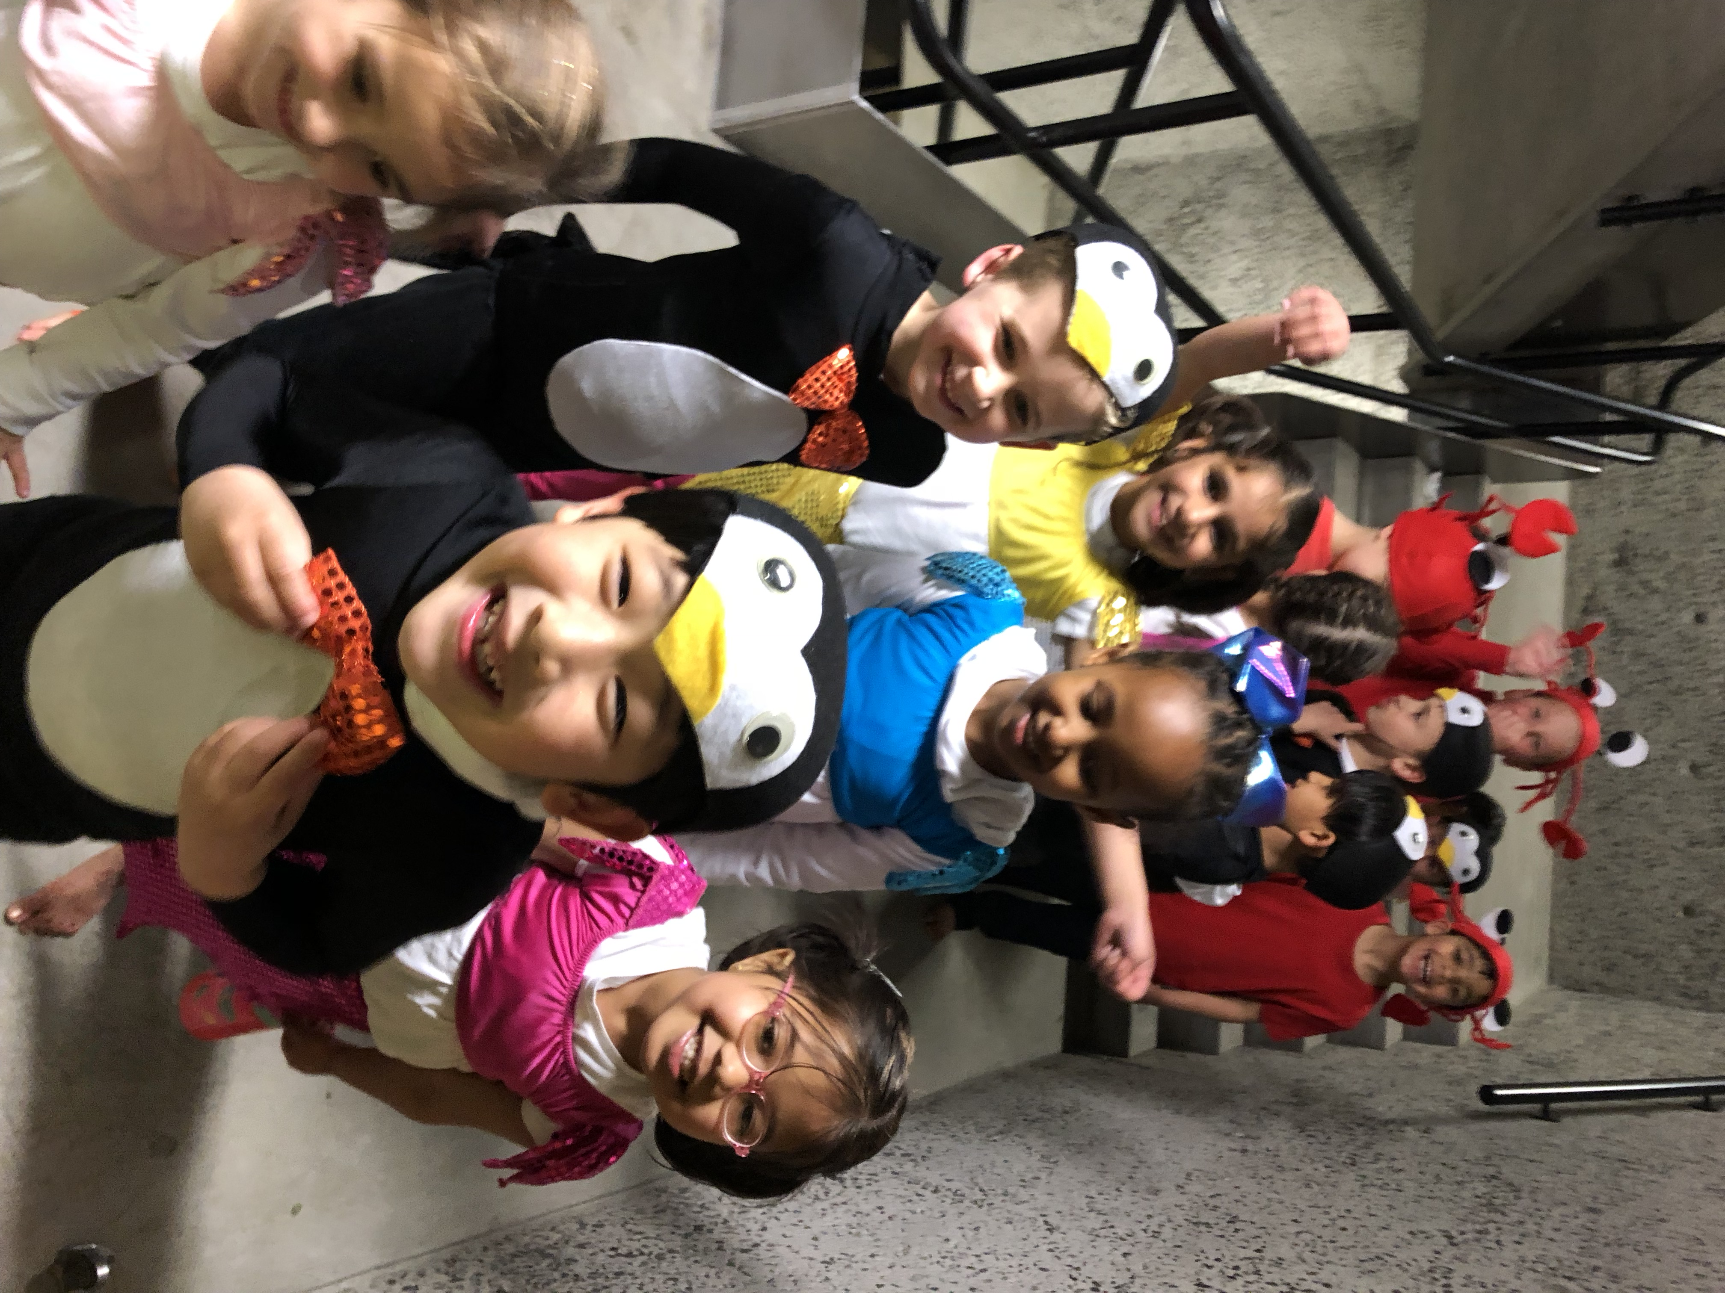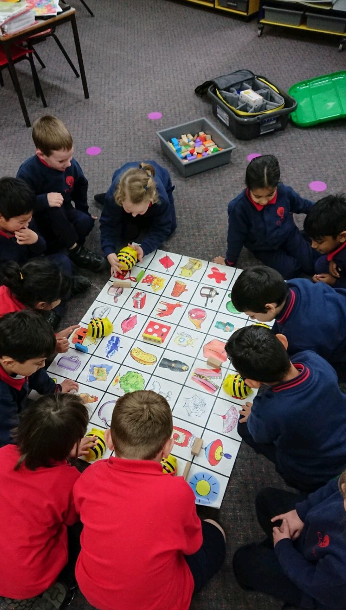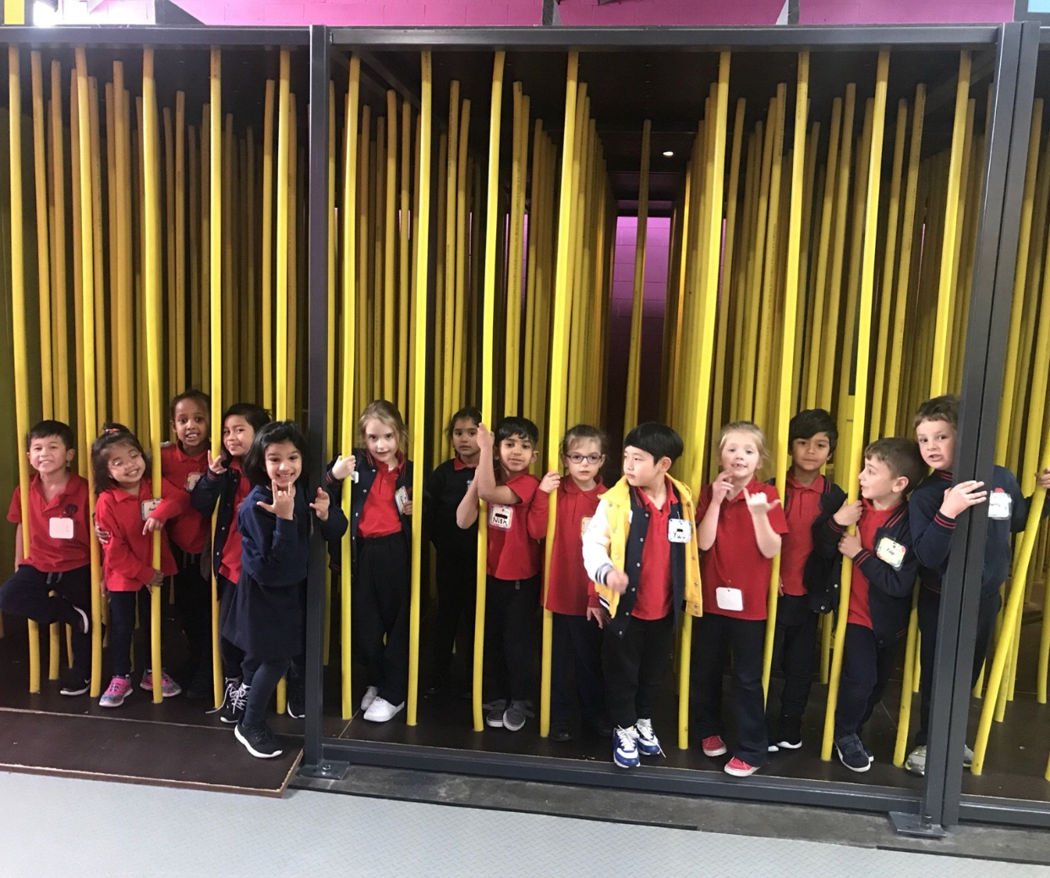Term 3 Highlights

